Lutheran Braille Workers Sharing the Light of Christ’s Love

$ 5,000
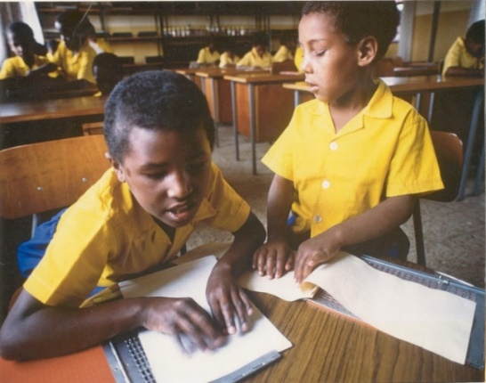
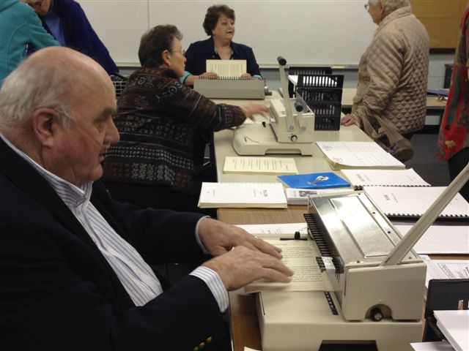
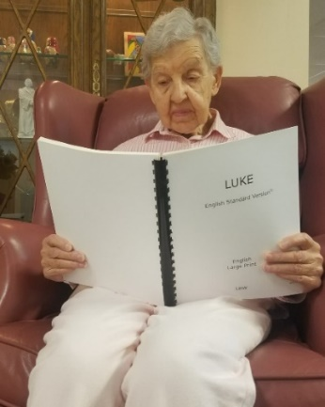
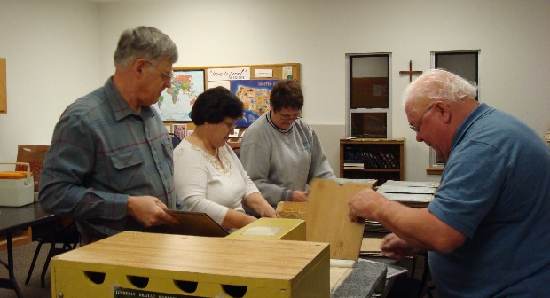

This grant from the LWML Washington-Alaska District will help support of the Lutheran Braille Workers’ ministry to increase production where possible, and to offset production costs of Braille, Specialized Large Print, and Audio materials at existing work centers within the United States and at the national headquarters. These monies will be used to purchase paper, cardboard, bindings, Zinc plates, maintenance kits, and other materials related to the production and distribution of Christian materials.

2022-2024 Biennium – LWML Washington-Alaska District

